The Newington Neighbourhood Plan and Referendum

A local Referendum will shortly be held on 2 November in the designated Newington Neighbourhood Plan area, which is in the vicinity of the MKM Stadium, as illustrated in the map below. This is your opportunity to vote, as you will get voting slips through the post shortly, in shaping the neighbourhood in which you live and in supporting new development proposals and in protecting/better maintaining parts of the area and buildings. If supported by local residents it will be the first adopted Neighbourhood Plan in the city, to sit alongside Hull City Council’s Local Plan.
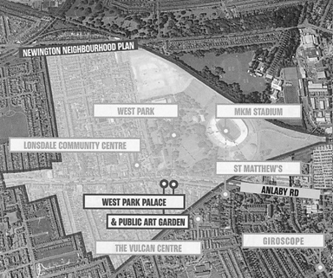
‘The Angel Fish’
Map showing the designated area of the Newington Neighbourhood Plan
resembling an ‘Angel Fish’ with the MKM Stadium as the eye of the fish.

Where’s Newington?
Roughly the area on Anlaby Road between West Park and the Anlaby Road / Boothferry Road roundabout, Newington has been a recognised and distinctive area since the1620’s. Drained and built up in the 1850’s the boundary of Hull was extended into Newington in 1882.

What is a Neighbourhood Plan?
A neighbourhood plan sets out planning policies for an area. It permits communities to address issues related to land use and gives them the power to develop a shared vision for their neighbourhood and shape its development and growth.

Who wrote the Newington Neighbourhood Plan?
The Plan has taken some time to be developed and was written by a Forum of over 50 local people supported by key local organisations, Planning Consultants and Hull City Council Officers. The Forum consulted widely with the local community and organisations and met and held consultation events at numerous venues over several years.

What is in the Newington Neighbourhood Plan?
The overall vision of the plan is to improve the local environment including the social, economic and cultural provision in the area. Key aims of the plan are; To create a cleaner, healthier environment; To protect the heritage of the area; To improve existing open spaces and safeguard public footpaths and cycle routes; To improve the appearance of poorly maintained land and buildings; To bring vacant sites and buildings back into use; To encourage the provision of new and refurbished housing and to develop employment and educational programmes. Additionally, there are several legacy projects built into the plan; to bring the former Premiere Bar back into use as a community music and events venue and to hold an Annual Festival in West Park.

Why should I vote for the Newington Neighbourhood Plan?
You should vote for the plan if you want it to attain legal status as a statutory part of the development plan for the city covering the Newington Neighbourhood.

How can I find out more or get involved?
Full copies of the Newington Neighbourhood Plan can be viewed and downloaded from the Newington Neighbourhood Plan website https://thenewingtonplan.co.uk/
Public meetings to provide further information about all aspects of the plan are to be held at the Lonsdale Community Centre leading up to the referendum scheduled for Thursday 2nd November 2023.
For further information please call-in, telephone or email the Lonsdale community centre on:
(01482) 564691 office@lonsdalecc.org.uk

